**Report**

What Is IoT?

* The Internet of Things (IoT) is a network of physical items (or "things") that are implanted with sensors, software, and other technologies in order to connect and exchange data with other devices and systems through the internet. These devices range in complexity from common household items to sophisticated industrial equipment.

What is a smart home?

* A smart house is a home with internet-connected gadgets that allow for remote administration and monitoring of systems and appliances.
* The ‘smart' appliances can range from a coffee maker that can be programmed to prepare a fresh cup in the morning to a smart lighting system that dims the lights automatically after 9 p.m.

Problem Statement

* Some gadgets are meant to be plugged in and out of power outlets at different intervals, while others are supposed to be left connected in.
* All of this necessitates a human physically attending to each of the devices on a regular basis.
* All of this monitoring and control may be carried out without the need to be there or inside the house. Some gadgets, if not correctly managed, consume a lot of energy, resulting in additional power costs.

Objective

* To monitor and operate household appliances from afar.
* To save time and to make effective use of energy
* To have better control over your living environment and improve your freedom
* To make communication with relatives more convenient
* To enhance personal security
* To serve as a visual warning system in the event of an emergency.

Advantages of Home automation systems:

* Reduced installation costs
* First and foremost, because no cabling is required, installation expenses are considerably reduced. Wired systems need cabling, which is costly in terms of both material and expert wire laying (for example, through walls).
* System scalability and easy extension
* When a network expansion is required owing to new or altered needs, deploying a wireless network is very useful. Unlike wired systems, where cabling expansion is time-consuming. As a result, wireless installations are a critical investment.
* Aesthetical benefits
* This feature not only helps to cover a wider area, but it also helps to meet aesthetic criteria. Representative buildings with all-glass architecture and historical structures where cable laying is prohibited due to design or conservatory constraints are examples.
* Integration of mobile devices
* Associating mobile devices such as PDAs and Smartphones with the automation system is now feasible everywhere and at any time thanks to wireless networks, as the specific physical location of a device is no longer necessary for a connection.

Methodology

* We will utilize the Cisco packet tracer to construct a smart house, which includes several smart items used for home automation such as a smart fan, smart window, smart door, smart light, smart siren, smart camera, and many sensors.
* Home Gateway is utilized to operate this smart object and sensor since it provides a programming environment for controlling smart objects linked to it as well as controlling mechanisms by registering smart devices with Home Gateway.
* A web interface offered by the Home Gateway may be used to remotely administer the IoE device. The internal (LAN) IP address of the Home Gateway is 192.168.25.1, but it may also be reached through its Internet-facing IP address. 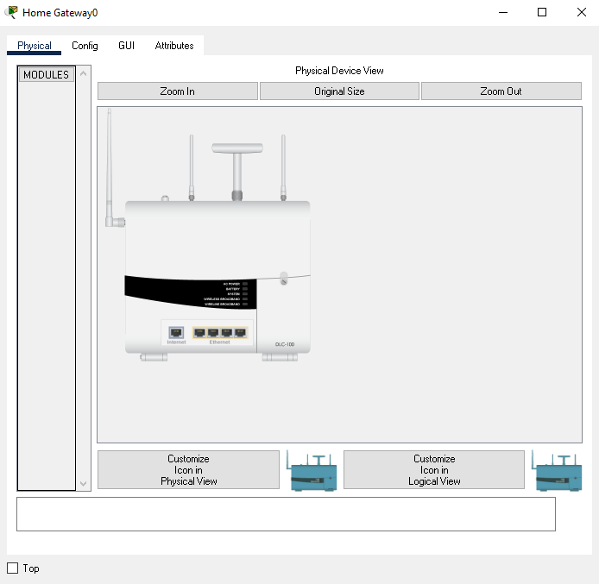

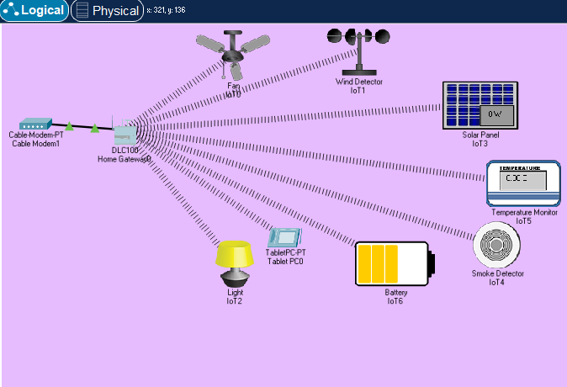

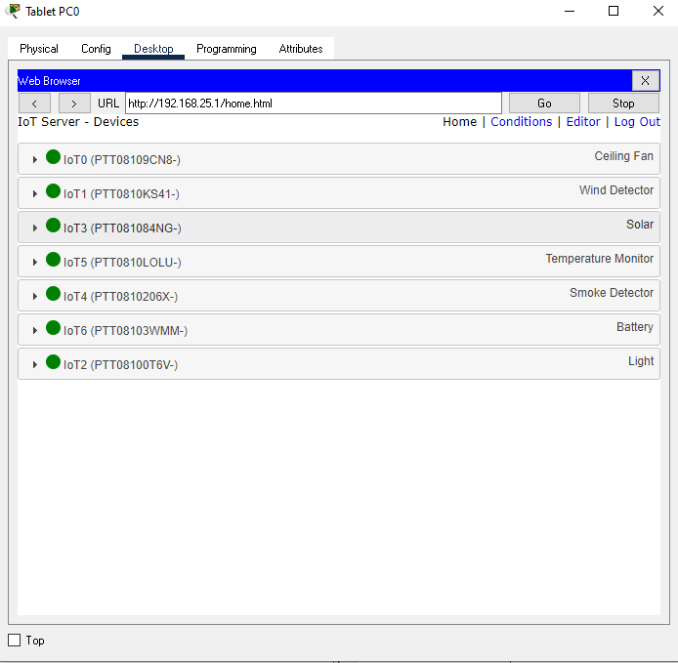

Conclusion

* Because this version featured different IOE devices used for home automation, I built a smart home utilizing the newly available Cisco packet in this project. I utilized a home gateway to register smart devices and operate them, as well as a Microcontroller (MCU) to link various sensors and IOE devices. MCUs also provide a programming environment for managing various devices, with a variety of programming languages to choose from.
* As we all know, the world is becoming increasingly linked, and IoT contributes to this trend. Many IT entrepreneurs have already begun to profit from the Internet of Things. Putting profits aside, if we consider the IoT in a larger sense, we may conclude that it has a bright future and will transform the globe in the next five years. The Internet of Things is similar to clay that can be molded.
* By connecting basic appliances to the Internet of Things, home automation has been experimentally proved to operate well, and the appliances have been successfully controlled remotely over the internet. The proposed system not only monitors sensor data such as temperature, gas, light, and motion sensors but also actuates a process based on the need, such as turning on the light.
* It also records the sensor parameters in a timely manner on the website (database). This will allow the user to assess the state of different metrics in the house at any time and from any location.